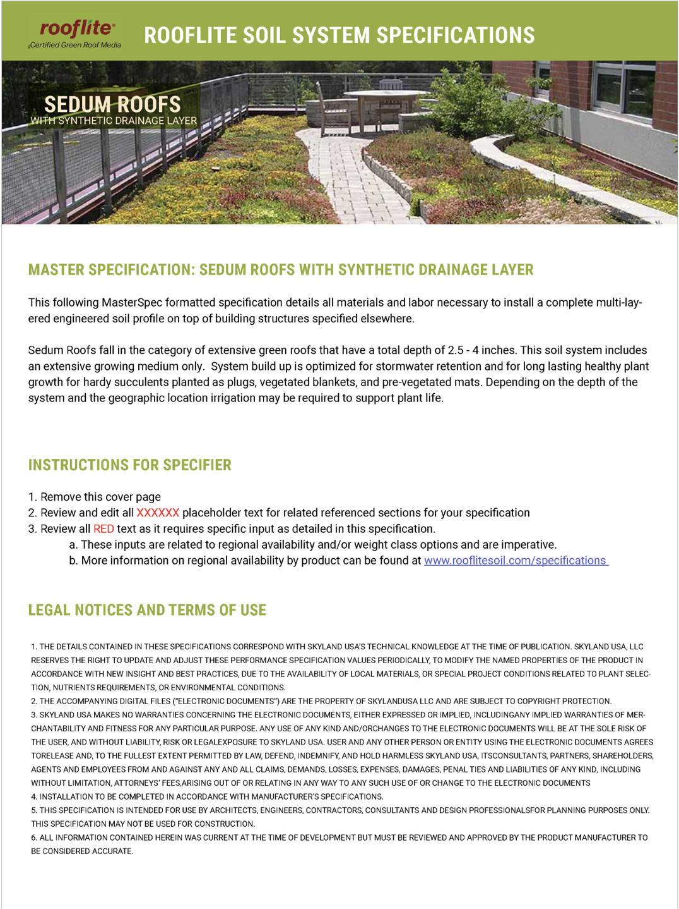

REV4-08/2023 Skyland USA, PO Box 159, Landenberg, PA 19350 610.268.0017 rooflitesoil.com ©2023 SKYLAND USA

PART 1 - GENERAL

1.1 SUMMARY

A. This Section specifies all labor and materials necessary to install an engineered soil profile on top of building structures specified elsewhere. Sedum Roofs fall in the category of extensive green roofs that have a total depth of 2.5 - 4 inches. This soil system includes an extensive growing medium only. System build up is optimized for stormwater retention and for long lasting healthy plant growth for hardy succulents planted as plugs, vegetated blankets, and pre-vegetated mats. Depending on the depth of the system and the geographic location irrigation may be required to support plant live.

B. Related requirements specified elsewhere include:
1. Waterproofing - Section xxxxxx
2. Insulation - Section xxxxxx
3. Synthetic Drain Layer - Section xxxxxx
4. Separation Layer - Section xxxxxx
5. Other green roof components including drainage - Section xxxxxx
6. Plantings - Section xxxxxx
7. Maintenance - Section xxxxxx

1.2 REFERENCES

A. Referenced standards:
1. ASTM D 422-63 Standard Test Method for Particle Size Distribution
2. ASTM E 2399: Standard Testing Method for Maximum Media Density for Dead Load Analysis
3. ASTM E 2777 Standard Guide for Vegetative (Green) Roof Systems
4. FLL - Forschungsgesellschaft Landschaftsentwicklung Landschaftsbau e.V. (The Landscape Development and Landscaping Research Society) latest English edition

5. TMECC -Test Methods for the Examination of Composting and Compost (latest edition)

  - DEFINITIONS (per ASTM E2777-14)

- Extensive Growing Medium:
An engineered planting media for multi-course extensive vegetative (green) roof systems with optimized performance characteristics for extensive green roofs promoting long lasting and healthy plant growth for hardy succulents, perennials, and grasses.
- System Provider:
Company that provides all materials required for installation of this Sedum roof soil profile.

1.4 SYSTEM DESCRIPTION

A. All components must be tailored to the whole system to optimize performance.
Use a single source system provider for all system components.

B. Design Requirements for Sedum Roofs:

1. The only system component is a layer of extensive growing medium. Sedum Roofs are extensive green roofs with a growing medium depth between 2.5 and 4 inches. Synthetic drainage layers specified elsewhere may vary in depth but must include a separation fabric as top layer. The intended plant palette consists of hardy succulents. Suitable native species may be used to increase diversity and/or to adjust to local climatic conditions.
C. Performance Requirements:

1. The Sedum Roof system shall support long lasting and healthy plant growth.
2. Build a stable structure of mineral components, which is not prone to loss of volume and change of physical properties.
3. Retain and distribute moisture for plants and stormwater mitigation while efficiently draining excess water.

1.5 SUBMITTALS

A. Product Data:
1. System Provider’s technical literature showing compliance of all components with specified requirements.
2. Certified laboratory reports demonstrating compliance of the proposed media with this Specification.

B. Shop Drawings:
1. A CAD drawing showing the system build up including the thickness of each system layer.

C. Samples for approval by the Landscape Architect:

Quantity Size Description
1 16 oz Extensive Growing Medium

D. Certify all materials for the Sedum Roof System come from one single source System Provider.

1.6 DELIVERY, HANDLING, STORAGE
A. Loose Bulk Media: Dump bulk growth media or granular drainage on paved areas only. Avoid any contamination by weed seeds, foreign materials, or debris. Tarp stockpile and maintain proper moisture content, and condition. Avoid sloped surfaces and site runoff in stockpiling locations.

B. Crane Strapped Super Sacks (Flexible Intermediate Bulk Containers): Super Sacks are delivered on pallets. Extreme care should be used when lifting sacks. Damage or injury to persons or property is a potential risk. Lift sacks directly from truck with appropriately rated lifting equipment according to handling instructions on sack labels. Sacks may be staged onsite if moved and stored on pallets. Do not store onsite for more than thirty days without consulting System Provider for detailed instructions. Inspect all sacks for damage before lifting. Do not lift damaged or punctured bags.

C. Retail Sized Packaging: Retail sized packages are delivered on stacked and stretch wrapped pallets. Keep material in packaging until use.

D. Handle all components in accordance with the System Provider’s instructions. Refer to PART 3 for installation instruction.

1.7 QUALITY ASSURANCE

A. The work of this section shall be performed by a contractor that specializes in green roof installations. This company shall document the successful completion of at least 3 previous projects similar in scope.

B. All test results must be from independent and qualified laboratories. Laboratories may include, but are not limited to:
- Agricultural Analytical Services Laboratory, Penn State University, Tower Road, University Park, PA 16802
- CTL Group, 5400 Old Orchard Road, Skokie, IL 60077

C. Ensure that all components are engineered to be incorporated into a Sedum Roof System via a single source by System Provider in order to ensure the performance requirements specified in Section 1.4 B

PART 2 - MATERIALS

2.1 SEDUM ROOF WITH A SYNTHETIC DRAINAGE LAYER

A. Description: An extensive green roof system with a total depth of 2.5 - 4 inches consisting of an extensive growing medium on top of a synthetic drainage and filter layer specified elsewhere.

B. All specified growing medium component shall be obtained from the following supplier:

Skyland USA, LLC – Main Office
P.O. Box 159
Landenberg, PA 19350
Tel. 610.268.0017
E-Mail: sales@rooflitesoil.com

C. EXTENSIVE GROWING MEDIUM – rooflite® extensive XXX

Description:
A planting medium for extensive vegetative (green) roof systems with a separate synthetic drain layer, designed to retain stormwater and to promote long lasting vigorous plant growth, and which meets the requirements described in ASTM E2777-14 Standard Guide for Vegetative (Green) Roof Systems and detailed below. rooflite® extensive is a precisely balanced blend of carefully selected lightweight mineral aggregates and premium organic components, like USCC STA approved compost complying with the following technical and performance requirements:

1. Particle Size Distribution (ASTM D422-63)
a. Proportion of particles < 0.05 mm ≤ 15 %
b. Proportion of particles < 0.25 mm # 60 mesh 5 - 30 %
c. Proportion of particles < 1.00 mm # 18 mesh 10 - 50 %
d. Proportion of particles < 2.00 mm # 10 mesh 30 - 70 %
e. Proportion of particles < 3.20 mm 1/8-inch mesh 40 - 80 %
f. Proportion of particles < 6.30 mm 1/4-inch mesh 65 - 95 %
g. Proportion of particles < 9.50 mm 3/8-inch mesh 80 - 100 %
h. Proportion of particles <12.50 mm 1/2-inch mesh 100 %

2. Bulk Density at max. water-holding capacity (ASTM E2399) xx - xx lb/ft³

{SPECIFIER – USE PROJECT SPECIFIC VALUE
and/or visit www.rooflitesoil.com for regional product options

Note: rooflite extensive is a product line that is available in different saturated weight classes. These weight classes are designed to guide you in choosing the best option for your project based on your weight requirements. Each weight class is identified by a number that corresponds to the typical weight for fully saturated media based on ASTM E2399. Depending on your specific region, the following weight classes may be available for rooflite extensive:

• extensive 500: saturated weight 50-60 lbs/ft3
• extensive 600: saturated weight 60-70 lbs/ft3
• extensive 700: saturated weight 70-80 lbs/ft3
• extensive 800: saturated weight 80-90 lbs/ft3

Please confirm regional availability at www.rooflitesoil.com/specifications or call our team at 610.268.0017. Note: All Density Measurements reflect typical ranges for the respective rooflite products. For more detailed information please inquire about latest test results.}

3. Water/Air Measurements (ASTM E2399)
a. Total Pore Volume > 50 %
b. Maximum water-holding capacity 35 - 60 %
c. Air-filled porosity at max water-holding capacity > 7 %
d. Water permeability (sat. hydraulic conductivity) 0.024 - 2.83 in/min

4. pH (in CaCl₂) 6.0 - 8.5

5. Soluble salts (water, 1:10, m:v) ≤ 3.5 g (KCl)/L

6. Organic Matter Content LOI at 500°C (SM 2540 G) 25 – 65 g/L

7. Nutrient Retention Capacity / Cation Exchange Capacity (CEC) > 6 meq/100 g

D. TESTING mETHODS
All values are based on compacted materials according to laboratory standards and testing methods defined by FLL - Forschungsgesellschaft Landschaftsentwicklung Landschaftsbau e.V. (The Landscape Development and Landscaping Research Society) if no other standard has been specified. Nutrients of newly blended products may temporarily exceed upper limits.

E. RELATED MATERIALS

    - Waterproofing as specified in Section xxxxxx
    - Synthetic Drainage Layer specified in Section xxxxxx
    - Separation Layer specified in Section xxxxxx
    - Plants as specified in Section xxxxxx
    - Irrigation as specified in Section xxxxxx
    - Other green roof components specified in Section xxxxxx

PART 3 EXECUTION

3.1 PREPARATION & EXAMINATION

- Install each component of the Sedum Roof System in accordance with the System Provider’s instructions on top of
1. Waterproofing System as specified in Section xxxxxx
2. Drainage System as specified in Section xxxxxx
3. Separation Layer as specified in Section xxxxxx

- Coordinate activities with other project contractors so that there is no growing media disturbance from traffic or other construction activities subsequent to placement.

- Ensure that underlying roof components have been installed and signed off prior to the installation of the Sedum Roof System.

3.2 PROTECTION
- All finished surfaces must be protected to prevent staining or infiltration of loose growing medium or plant materials into drainage structures or areas beyond zones defined for growing medium.
- Heavily traveled areas (e.g., corridors for transporting media to the working areas) must be protected in a manner approved by Construction Manager to prevent damage to finished Work.

3.3 CHECK ROOF DRAINS

- Locate roof drains and check for proper water run-off.

- Protect roof drains during the installation of the Sedum Roof layers to avoid contamination or clogging of drain pipes.

- Do not cover roof drains with any Sedum Roof components. All roof drains located within the Sedum Roof area must be accessible for maintenance and inspection. Inspection chambers or drain boxes prevent the clogging of water outlets by roots or soil and allow for inspection of these critical points.

3.4 INSTALL GROWING MEDIUM

- Verify that the green roof drainage system and filter fabric have been installed and accepted.

- Place the growing medium directly on the separation fabric and level the surface evenly.

- Growing media shall be placed carefully to avoid damage or displacement of other materials such as walls, edging, paving, drainage components, filter fabric, or any components of the waterproofing system.

- Growing media shall be placed to within 1 inch greater than final grade or to a depth of no greater than 8 inches and compacted as described below. For final grades less than 8 inches only one round of compaction shall be performed, and remaining soil loosely placed such that top of growing media exceeds final grade by 1 inch.

- Compaction shall be performed with a 200 – 300 lb. landscape roller and/or lightly compacted with a hand held, non-mechanical tool to achieve a uniform growing medium compaction.
- Compress the growing medium to a degree where full exposure of body weight on one foot does not further reduce depth.
- Mechanical compactors including plate compactors are not acceptable because they can over compact the media and can damage the underlayment.
- Proper compaction is crucial to avoid loss of volume and to maintain a healthy root environment.

F. Adjust the final compressed growing medium surface to the specified depth as indicated on the grading plan or Sedum Roof detail. See Detail xxxxxx

END OF SECTION

